Markdown and Stata example
Niels Henrik Bruun,
Section for General Practice,
Dept. Of Public Health,
Aarhus University

Headers

Header 2

Header 3

Header 4

Header 5

Header 6

Text and bullits
Text text text ….
Bullits:
- Bullit 1
  - sub bullit 1
  - sub bullit 2
- Bullit 2
  - point 1
  - point 2

Formulas
Inline math $c^{2}=a^{2}+b^{2}$ are possible
A formula on a line itself:
$$f(x)=\frac{a⋅x^{2}-b⋅x}{e^{x}}$$

Footnotes
Here is a footnote reference, and another.
This paragraph won’t be part of the note, because it isn’t indented.

Adding code or and output

Import data and show a summary using sumat:
sysuse auto, clear
 |  | n | missing | unique
foreign(Domestic) | Price | 52 | 0 | 52
 | Mileage(mpg) | 52 | 0 | 17
 | Make and Model | 52 | 0 | 52
foreign(Foreign) | Price | 22 | 0 | 22
 | Mileage(mpg) | 22 | 0 | 13
 | Make and Model | 22 | 0 | 22

Using metadata
Name | Index | Label | Value Label Name | Format | Value Label Values | n | unique | missing
make | 1 | Make and Model |  | %-18s |  | 74 | 74 | 0
price | 2 | Price |  | %8.0gc |  | 74 | 74 | 0
mpg | 3 | Mileage (mpg) |  | %8.0g |  | 74 | 21 | 0
rep78 | 4 | Repair Record 1978 |  | %8.0g |  | 69 | 5 | 5
headroom | 5 | Headroom (in.) |  | %6.1f |  | 74 | 8 | 0
trunk | 6 | Trunk space (cu. ft.) |  | %8.0g |  | 74 | 18 | 0
weight | 7 | Weight (lbs.) |  | %8.0gc |  | 74 | 64 | 0
length | 8 | Length (in.) |  | %8.0g |  | 74 | 47 | 0
turn | 9 | Turn Circle (ft.) |  | %8.0g |  | 74 | 18 | 0
displacement | 10 | Displacement (cu. in.) |  | %8.0g |  | 74 | 31 | 0
gear_ratio | 11 | Gear Ratio |  | %6.2f |  | 74 | 36 | 0
foreign | 12 | Car type | origin | %8.0g | 0 “Domestic” 1 “Foreign” | 74 | 2 | 0

Regression coefficients estimates and graphs
Do a regression and show CI for regression coefficients:
regress price mpg weight
matrix ci = r(table)'
matrix ci = ci["mpg".."weight", "b"], ci["mpg".."weight", "ll".."ul"]
Printing the ci matrix:
Regression CIs
 | b | ll | ul
mpg | -49.512 | -221.302 | 122.278
weight | 1.747 | 0.468 | 3.025
Add a plot (Note some code is deliberately hidden in pandoc output)

scatter price mpg, name(scatter, replace)
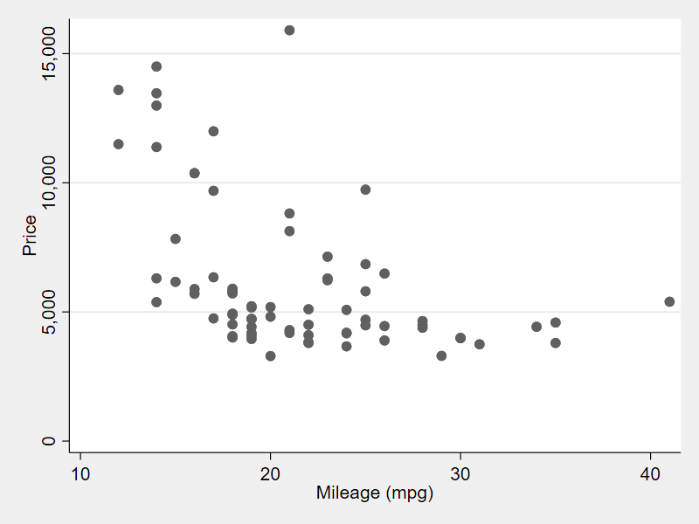
Scatterplot caption
Insert hyperlink

Here is the footnote.
Here’s one with multiple blocks. Subsequent paragraphs are indented to show that they belong to the previous footnote. { some.code } The whole paragraph can be indented, or just the first line. In this way, multi-paragraph footnotes work like multi-paragraph list items.

